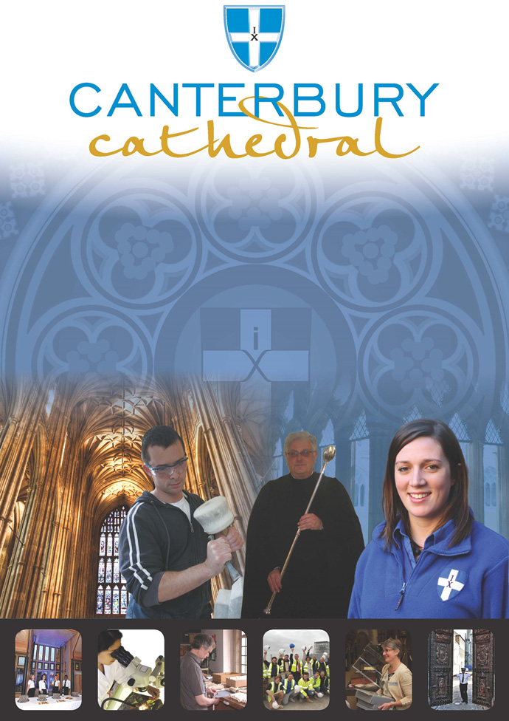

PROFILE OF CANTERBURY CATHEDRAL
St Augustine, the first Archbishop of Canterbury, arrived on the coast of Kent as a missionary to England in 597 AD. He came from Rome, sent by Pope Gregory the Great. It is said that Gregory had been struck by the beauty of Angle slaves he saw for sale in the city market and dispatched Augustine and some monks to convert them to Christianity. Augustine was given a church at Canterbury (St Martin’s, after St Martin of Tours, still standing today) by the local King, Ethelbert whose Queen, Bertha, a French Princess, was already a Christian. This building had been a place of worship during the Roman occupation of Britain and is the oldest church in England still in use. Augustine had been consecrated a bishop in France and was later made an archbishop by the Pope. He established his seat within the Roman city walls (the word cathedral is derived from the Latin word for a chair ‘cathedra’, which is itself taken from the Greek ‘kathedra’ meaning seat.) and built the first cathedral there, becoming the first Archbishop of Canterbury. Since that time, there has been a community around the Cathedral offering daily prayer to God; this community is arguably the oldest organisation in the English speaking world. The present Archbishop, The Most Revd Justin Welby, is 105th in the line of succession from Augustine.
Augustine’s original building lies beneath the floor of the nave– it was extensively rebuilt and enlarged by the Saxons, and the Cathedral was rebuilt completely by the Normans in 1070 following a major fire. There have been many additions to the building over the last nine hundred years, but parts of the quire and some of the windows and their stained glass date from the 12th century.
By 1077, Archbishop Lanfranc had rebuilt it as a Norman church, described as “nearly perfect”. A staircase and parts of the North Wall – in the area of the North West transept also called the Martyrdom – remain from that building.
During the Second World War, the Precincts were heavily damaged by enemy action and the Cathedral’s Library was destroyed. Thankfully, the Cathedral itself was not seriously harmed, due to the bravery of the team of fire watchers, who patrolled the roofs and dealt with the incendiary bombs dropped by enemy bombers.
Today, the Cathedral stands as a place where prayer to God has been offered daily for over 1,400 years; nearly 2,000 services are held each year, as well as countless private prayers from individuals. The Cathedral offers a warm welcome to all visitors – its aim is to show people Jesus, which we do through the splendour of the building as well as the beauty of the worship.

THE WORK OF THE CATHEDRAL
The work of the Cathedral is carried out by over 300 paid staff, supported by some 500 volunteers. The ‘corporate body’ responsible for the management of the Cathedral is the Chapter of Canterbury who are advised by the Cathedral Council and the College of Canons.

The Chapter of Canterbury (Chapter)
The Chapter are responsible for all aspects of the day-to-day management of the Cathedral. Chapter comprises the Dean, the Residentiary Canons, the Receiver General and four additional persons appointed by the Archbishop.

The Cathedral Council
The Council represents the Cathedral community as well as the wider local and regional community. It has 20 members, drawn from a wide variety of organisations. Its duty is to further and support the work of the Cathedral Church in spiritual, pastoral, evangelistic, social and ecumenical areas.

The College of Canons
The College of Canons is composed of 30 Honorary, Lay and Provincial Canons, appointed by the Archbishop and it supports the life of the Cathedral in many different ways.

The Cathedral Trust
The Cathedral Trust is a separate charity that is solely for the benefit of the Cathedral. Since 1974, it has assisted with the restoration, maintenance and improvement of the fabric and contents of Canterbury Cathedral and the provision, promotion and encouragement of music
The Cathedral is well-known all over the world and we welcome more than 1 million visitors and worshippers every year. The Cathedral is more than just a beautiful old building and heritage site; it is a working, living church which maintains a tradition of welcome and worship that has been practiced here for over 1400 years.

Friends
The Friends of Canterbury Cathedral was founded in 1927 by the distinguished scholar and poet Dean George Allen Kennedy Bell. The Organisation was the first of its kind in the world.
The Friends are the Cathedral’s fan club. Admirers of the building, its history and its community, Friends are a part of the Cathedral and work together to preserve it forever, contributing financially - and directly – to many individual and vital projects.

The Cathedral Shop
The Canterbury Cathedral Shop is a large gift shop in the heart of the city of Canterbury. It has an impressive range of high quality gifts, mostly British, and their own exclusive award winning designs.
The Shops wide range of merchandise includes replica historical artefacts, books and CD’s of the world-famous Canterbury Cathedral choir.

THE CANTERBURY JOURNEY
The Canterbury Journey is a major project being delivered over five years in partnership with the National Lottery Heritage Fund (NLHF) and it continues to play a significant role in the Cathedral’s life until it’s conclusion in October 2021.
The total project cost is £24.7 million. The NLHF awarded the Cathedral a total grant of £13.8 million - to which is being added a magnificent £10.9 million raised by the Canterbury Cathedral Trust, from The Friends of Canterbury Cathedral and many other private and charitable sources in the UK and USA.
The Canterbury Journey will achieve a radical transformation in the accessibility and sustainability of Canterbury Cathedral. It will safeguard an iconic building which embodies England’s story, increase the number and broaden the range of those who journey to it, and enrich their experience.
A new Visitor Centre with a free Viewing Gallery of one of Europe’s most important churches and a dedicated Community Studio. New trails will guide visitors through the Cathedral and its newly landscaped Precincts, interpreting their journey and revealing unseen treasures from Canterbury’s past. New, young, diverse and hard-to-reach audiences will join the journey as a programme of engagement and outreach to schools and communities unfolds. A new pass scheme will swell the company of contemporary visitors and deepen the Cathedral’s relationship with its neighbours. The fabric of the western end of the Cathedral, currently endangered, will be restored and enhanced, allowing Canterbury’s journey to continue.
The project is formed of three complementary programmes – responding to the most urgent needs for our heritage, people, and communities:

Heritage
- Repair and restoration of the West end of the Nave and Christ Church Gate;
- Landscaping of the Western Precincts;
- Improved physical access to the Cathedral and its collections; and
- A commitment to Conservation in Action – engaging people with the work of our craftspeople and the work of the Cathedral.

People
- Interpretative Pilgrims’ Trails – developing the ways people connect with and interpret the site, utilising digital technology and opening up the Cathedral’s historic collections to them; and
- Schools on the Journey – increasing the depth of experience, and the numbers and range of schoolchildren able to enjoy the Cathedral, and building the Cathedral’s capacity to reach out to schools.

Communities
- Visitor Centre – an exciting new space and Viewing Gallery to enable visitor reception, community activities, interpretation and orientation, as well as new retail facilities;
- Community Studio – a new dedicated resource for delivering the Activity Plan and for community groups to use;
- Community Pilgrimage – new programme of events and courses to offer a wide range of people the chance to discover and grow their talents; and
- Canterbury Pilgrim’s Pass – replacing the existing pass system to encourage the local community to access their Cathedral regularly.

ROLE PROFILE
The Volunteer Community Engagement Ambassador will be responsible to the Community Engagement Manager.

Purpose/ summary of role

This role is supported by The Canterbury Journey, which aims to engage new, hard-to-reach and diverse audiences with heritage and the collections through the Activity Plan. The Activity Plan volunteer programme enables training and new skills development in interpretation, collections care, informal learning, community engagement and outreach to help increase knowledge transfer and employability within the heritage sector.

Successful candidates will assist the Community Engagement Manager with the delivery of a programme of activities, inspired by Canterbury Cathedral’s heritage and the historic collections.

Activities within the Cathedral Precincts will take place during school holiday weekdays and occasionally evenings and weekends include activities for families, special themed talks and tours for adults, multi-sensory visits for people with disabilities, an annual youth conference, creative interpretation, exhibitions, screenings, presentations, projects, workshops and open days.

The outreach programme extends to schools and community groups primarily in Shepway, Swale and Thanet, and the Canterbury District.

When agreeing to do outreach, the Volunteer Community Engagement Ambassador will attend and take part in the setting up and running of activities at community events such as festivals, creative workshops, and family fun days as well as working with partnering organisations such as the Garden Gate Project in Margate and Strange Cargo in Folkestone.

Description of tasks and activities

- To be the public face of Canterbury Cathedral and The Canterbury Journey project.
- To engage directly with the public.
- To promote Canterbury Cathedral, its heritage and the historic collections.
- To promote activities and events.
- To work with people of all ages, physical and learning abilities, nationalities and backgrounds.
- To help set up and tidy away resources.
- To adhere to good health and safety awareness and practice.
- To gather feedback from event participants.
- To complete evaluation reports.

Time Commitment

Time commitment will be matched to specific activities and the availability of the volunteer and will be agreed in advance of commencement.

Skills

Our volunteers will need the following skills to successfully engage with a wide range of audiences.

- Outgoing, friendly and proactive character.
- Emotional intelligence and empathy.
- To be able to work with people of all ages and backgrounds.
- Excellent communication skills.
- To be able to explain things simply to people at their own level.
- Creative flair.
- A keen interest in one or more of the following areas: archaeology, art, craft, drama (role play), history, science, storytelling.
- A commitment to develop a good knowledge of Canterbury Cathedral and its collections (relevant to the needs of the role).
- Team player.
- A self-starter able to work on your own initiative.
- Computer literate an advantage (but not essential).
- Clean driving licence for outreach work an advantage (but not essential).
- Being able to use your own initiative but to ask for help as and when needed.
- Good timekeeping and a strong commitment to honouring agreed volunteer time slots.

Training and Support

- Induction to Canterbury Cathedral.
- Training for the role.
- Volunteer handbook.
- Regular updates on forthcoming activities, and activity-specific training.
- Support, advice and guidance from the Learning and Participation Team.
- Child Protection guidance.
- Mandatory Cathedral DBS check.
- Mandatory safeguarding training.
- Public Liability cover.

Benefits to volunteer

- An opportunity to learn about Canterbury Cathedral’s heritage, historic collection and craft practices.
- The opportunity to develop new and existing skills and gain experience volunteering at a world heritage site.
- An introduction to events management, visitor engagement and heritage interpretation.
- A chance to meet new people and share your passion and skills with the public.
- A chance to be part of an exciting and interesting project.
- The satisfaction of knowing you are making an important contribution to Canterbury Cathedral, making it accessible to new audiences, many of whom haven’t visited before.

TERMS AND CONDITIONS

Trial Period
All new posts are subject to a trial period.

Training
Training needs are assessed continuously and appropriate training is provided for each activity.

Parking

The Dean and Chapter are not able to offer volunteers parking on site.

Volunteer benefits

We are able to offer a range of volunteer benefits including discounts in local shops, restaurants and sports centres.

EQUALITY STATEMENT
The Chapter of Canterbury recognises that discrimination and victimisation is unacceptable and that it is in the interests of the organisation and its employees and volunteers to utilise the skills of the total workforce. It is the aim of the organisation to ensure that no employee, volunteer or job applicant receives less favourable facilities or treatment (either directly or indirectly) in recruitment or employment on grounds of age, disability, gender / gender reassignment, marriage / civil partnership, pregnancy / maternity, race, religion or belief, sex, or sexual orientation.
This role profile is provided to assist the volunteer to know their principal duties. It may be amended from time to time in consultation with you.

HOW TO APPLY

- Register and submit an application Form via CV Minder
(http://canterbury-cathedral.org/community/employment/vacancies)
- Shortlisted applicants will be invited to attend an informal interview
- Offers will be subject to the receipt of 2 satisfactory references
- All new volunteers will carry out an Induction process
- Appropriate training will be given
- Appointees will be subject to a trial period

Contact Information if you would like to know more before applying:

Liam O’Driscoll, Community Engagement Manager

Email: Journey@canterbury-cathedral.org
Telephone: 01227 862796

Applications should be submitted using the Cathedral volunteer application form, and all sections must be completed. If you wish you may attach a copy of your CV to support your application.

Application forms can be found on our web pages at:

http://canterbury-cathedral.org/community/employment/vacancies

The closing date for this post is:

Sunday 1 December 2019.

Interviews are expected to take place:

On a rolling basis.

Training is expected to commence:

Immediately after appointment to the role.

